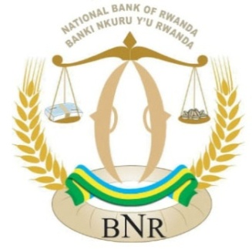

**NATIONAL BANK OF RWANDA**

**BANKI NKURU Y’U RWANDA**

**QUARTERLY CREDIT SURVEY REPORT**

**QUARTER FOUR 2018**

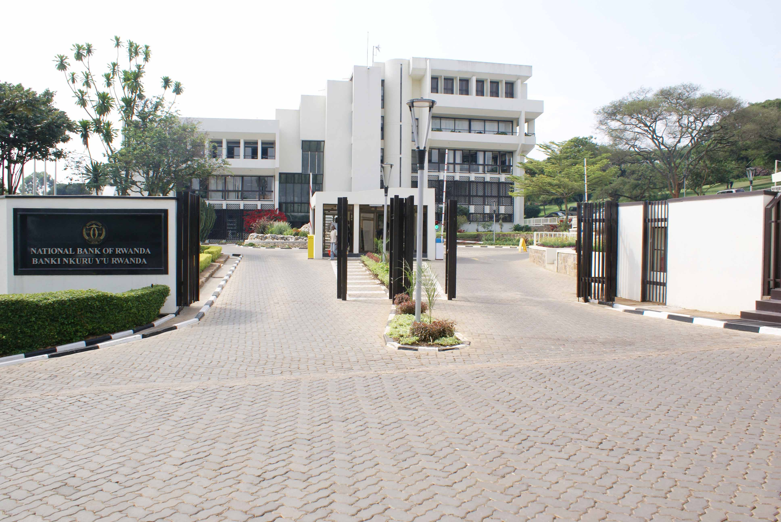

**BNR IDENTITY STATEMENT**

The National Bank of Rwanda strives to become a world class Central Bank that contributes to the economic growth and development by using robust monetary policy tools to maintain stable market prices. The bank embraces innovation, diversity and inclusiveness, economic integration and ensures financial stability in a free market economy**.**

**VISION, MISSION AND VALUES**

**VISION OF THE BANK**

The Vision of the Bank is to become a World-Class Central Bank

**MISSION OF THE BANK**

The mission of the Bank is to ensure price stability and a sound financial system

**THE BANK’S CORE VALUES**

**INTEGRITY**

We uphold high moral, ethical and professional standards for our people, systems and data

**ACCOUNTABILITY**

We are results-focused and transparent, and we reward according to performance

**MUTUAL-RESPECT AND TEAMWORK**

We keep ourselves in high spirit, committed to each other for success

**EXCELLENCE**

We passionately strive to deliver quality services in a timely and cost effective manner

**1. Background**

The general mission of the National Bank of Rwanda (NBR) is to ensure price stability and sound financial system. To achieve this, the NBR needs among others, to understand trends and developments in credit conditions. The NBR lending survey is an input to this work. The banking sector lending survey allows the NBR and other users to obtain valuable information about the developments in the credit market beyond the regularly reported data.

The lending survey conducted by the NBR captures past and prospective developments in the credit market. The main objectives of the survey are to: i) understand the drivers and constraints influencing credit growth, ii) enhance the understanding of the lending behavior and loan financing conditions among banks, and iii) get an insight into the loan supply and demand factors from the banks’ perspective.

**2. Methodology**

The lending survey is conducted through a structured questionnaire that enables the NBR to obtain quantitative and qualitative information directly from banks operating on Rwandan credit market. The questionnaire focuses on both the credit supply side (credit standards and terms and conditions for approving loans as stipulated by banks) and the credit demand side (demand for loans among households and enterprises as perceived by banks), and entails the most significant factors underlying changes in supply and demand.

The credit survey covers not only the observed evolution of credit standards and credit demand in the previous periods, but also the expected developments in the near future. The questionnaire is addressed to senior credit officers of banks to indicate their banks’ position in terms of demand for credit, approval of credit, credit standards and terms and conditions. In line with the aforementioned objectives, in this particular survey banks were asked about trends and developments in credit conditions during the year 2018 relative to the 2017, and prospects for the subsequent quarter ending March 2019. This report presents the results of the Q4 2018 survey conducted from January 14 to 17, 2019. The qualitative information contained in the survey are based on lenders’ own responses to the survey, and do not necessarily reflect the NBR’s views on credit conditions.

**3. Findings**

**The Demand for Credit**

During the year to December 2018, the demand for credit[1] decelerated in value but picked up in volume. In value, loan application increased by 3.4 percent (from FRW 1,196 billion in 2017 to FRW 1,237 billion in 2018), lower than 30 percent registered as at end December 2017. However, in terms of volume, the number of loans applications increased by 18.3 percent (from 318,166 in 2017 to 376,383 in 2018), more than 13 percent observed during the previous year. The higher increase of loan application in volume reflects the expansion of digital banking[2]. They are currently four banks (EQUITY BANK, CBA, BK and KCB) that offer this product of digital banking and the latter is attracting a number of borrowers due to lower transaction costs, easy conditions and short time for approval and disbursement. During the period under review, the number of digital borrowers increased to 67,852 in 2018 from 25,522 in 2017, whereas the amount borrowed rose to FRW 2.4 billion in 2018 from FRW 0.23 billion in 2017.

**Table 1: Loan Application in Value and Volume**

|  |  |  |  |  |  |
| --- | --- | --- | --- | --- | --- |
| **Loan applications** | **2016** | **2017** | **2018** | **% Change 16/17** | **% Change 17/18** |
| Loan application in value (FRW Billion) | 920 | 1,196 | 1,237 | 30.0 | 3.4 |
| Loan application in volume (Units) | 281,592 | 318,166 | 376,383 | 13.0 | 18.3 |

**Source:** Credit Survey Findings

**The Supply of Credit**

During the period under review, new authorized loans grew by 17.2 percent (from FRW 825.9 billion in 2017 to FRW 966.5 billion in 2018), higher than 4.6 percent recorded in 2017 and the average of 16.2 percent in the last five years. In 2018, banks approved 349,393 loans worth FRW 966.5 billion, compared to 278,898 loans worth FRW 824.9 billion that were approved in 2017. The growth of new loans is mainly attributable to increased lending appetite of banks especially in the second half of 2018. In this regards, the loan approval rate (which measures the proportion of loans approved vis a vis the total loans applied), increased from 69 percent in 2017 to 78.1 percent in 2018 in value and from 87.7 percent in 2017 to 92.8 percent in 2018 in volume.

**Figure 1: New Authorized Loans by Banks**

**Source:** Credit Survey Findings

Like in the previous year, the financing of transport and communication sector continued to shape up. New loans in transport and communication sector increased by 91.8 percent from FRW 73.5 billion in 2017 to FRW 141.1 billion in 2018 making it the third most financed sector following mortgage and trade sectors. The growth of new loans also improved for consumer loans (from 16.6 percent to 17.6 percent), agriculture (from -23.5 percent to 27.2 percent), manufacturing (from -5.7 percent to 17.2 percent), trade (from 8 percent to 9.8 percent) and in “other service”[3] (from -10.5 percent to 51.5 percent). However, lending appetite reduced in mortgage sector, which is the current most financed sector. As at December 2018, new loans in mortgage sector grew by 9.6 percent to FRW 252.9 billion from FRW 230.7 billion in 2017, lower than the growth of 18.3 percent observed in prior year. The deceleration of the growth of new loans in mortgage sector is linked to potential risks perceived in the construction of commercial buildings. Lending also continued to decline in risky sectors like mining and hotels. In 2018, new loans in mining and hotels dropped by 45.5 percent and 25.5 percent respectively, in addition to the contraction of 56.5 percent and 73.8 percent observed in 2017 respectively.

**Table 2: New Authorized Loans by Activity Sector**

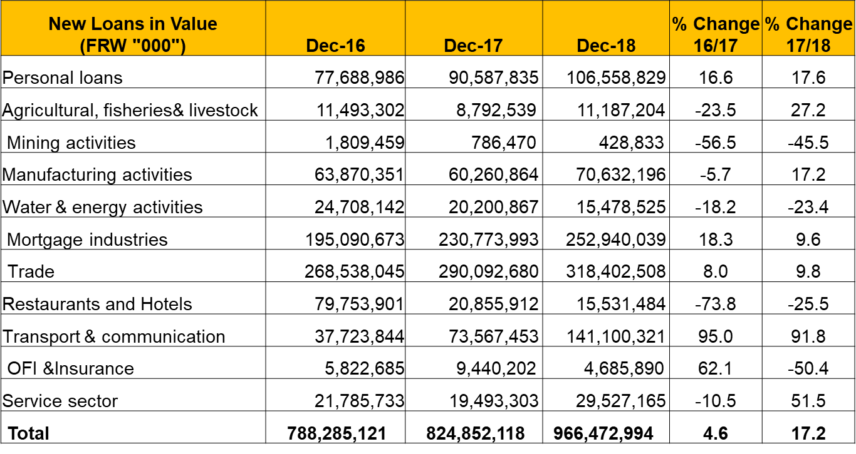**Source:** Credit Survey Findings

Banks have changed their credit stance in line with recent financial stability outlook. Though the overall rejection rate[4] decreased (form 31 percent to 21.9 percent in value and from 12.3 percent to 7.2 percent in volume), it varied in different sector and generally reflected the risk profile of a particular activity sector. The rejection rate reduced in sectors like agriculture, manufacturing, trade, transport and communication and other services, but increased in sectors like mining, mortgage and hotels. In particular, the deceleration of lending in mortgage and hotels has a bearing on low occupancy rate in hotels and commercial real estates as it was found out in the survey on commercial real estates and hotels. From a sample of top 63 loan applications that were rejected by banks, it emerged that they were concentrated in mortgage sector with a share of 53 percent in value. From banks’ perspective, the main reasons for high rejection rate include weak repayment capacity, inadequate collateral and insufficient own contribution.

**Figure 2: Rejection Rate by Economic Activity Sector**

**Source:** Credit Survey Findings

**Credit Terms and Conditions**

Credit terms and conditions are terms and conditions on which a bank provides credit to a customer after it has been approved. They mainly include the interest rate, maturity, types of collaterals and frequency of payment. Out of 16 banks operating on Rwandan credit market, 9 banks indicated that their overall terms and conditions remained unchanged, while 3 banks indicated that credit terms and conditions tightened and 4 banks indicated that the credit terms and conditions eased. From banks’ perspectives, the competition, cost of funds, capital and liquidity position were the main factors that contributed to easing of credit terms and conditions, while operating costs and the perception of risk were the main reasons for tightening credit terms and conditions. Tight credit terms and conditions mainly reflected collateral requirements and borrowers’ own contribution to the project.

**4. Expectations in 2019**

Banks expect lending to continue increasing in 2019. During the year 2019, most banks (11 banks) anticipate an increase of lending on basis of improved economic performance, increased demand for loans increased liquidity conditions and stable lending interest rate. Banks that foresee a dip in lending attribute it to tightness of underwriting credit standards mainly in form of collateral requirements. With regards to lending interest rate, banks expect the lending interest rate to remain broadly unchanged. The survey results indicate that majority of the banks (10 banks) expect their lending rates to remain unchanged, while 2 banks expect the lending interest rate increase and other 4 banks anticipate the lending interest rate to drop. Banks cited the competition in the industry, risk premium, liquidity and reduction of cost of funds as the major reasons driving these expectations on interest rate movement.

**Figure 3: Expectations on Lending**

**Source:** Credit Survey Findings

**5. List of Respondents**

1. AB BANK RWANDA Ltd

2. ACCESS BANK RWANDA Plc

3. BANK OF AFRICA RWANDA Plc

4. BANK OF KIGALI Ltd

5. BANQUE POPULAIRE DU RWANDA Ltd

6. COGEBANQUE Plc

7. COMMERCIAL BANK OF AFRICA RWANDA Plc

8. DEVELOPMENT BANK OF RWANDA Plc

9. ECOBANK RWANDA Ltd

10. EQUITY BANK RWANDA Plc

11. GT BANK RWANDA Plc

12. I&M BANK Plc

13. KCB RWANDA Ltd

14. UNGUKA BANK Ltd

15. URWEGO BANK Plc

16. ZIGAMA CSS



1. Demand for credit refers to the demand for new loans by borrowers as indicated by the volume and value of applications received.
2. Digital banking means that people can now borrow, save or pay with their mobile phones.
3. This includes health, education and professional activities.
4. The loan rejection rate is the ratio of the value or number of rejected loan applications by all banks to the number of loan applications received by the banks during the same period.