

**NATIONAL BANK OF RWANDA**

**BANKI NKURU Y’U RWANDA**

**QUARTERLY CREDIT SURVEY REPORT**

**THIRD QUARTER 2019**

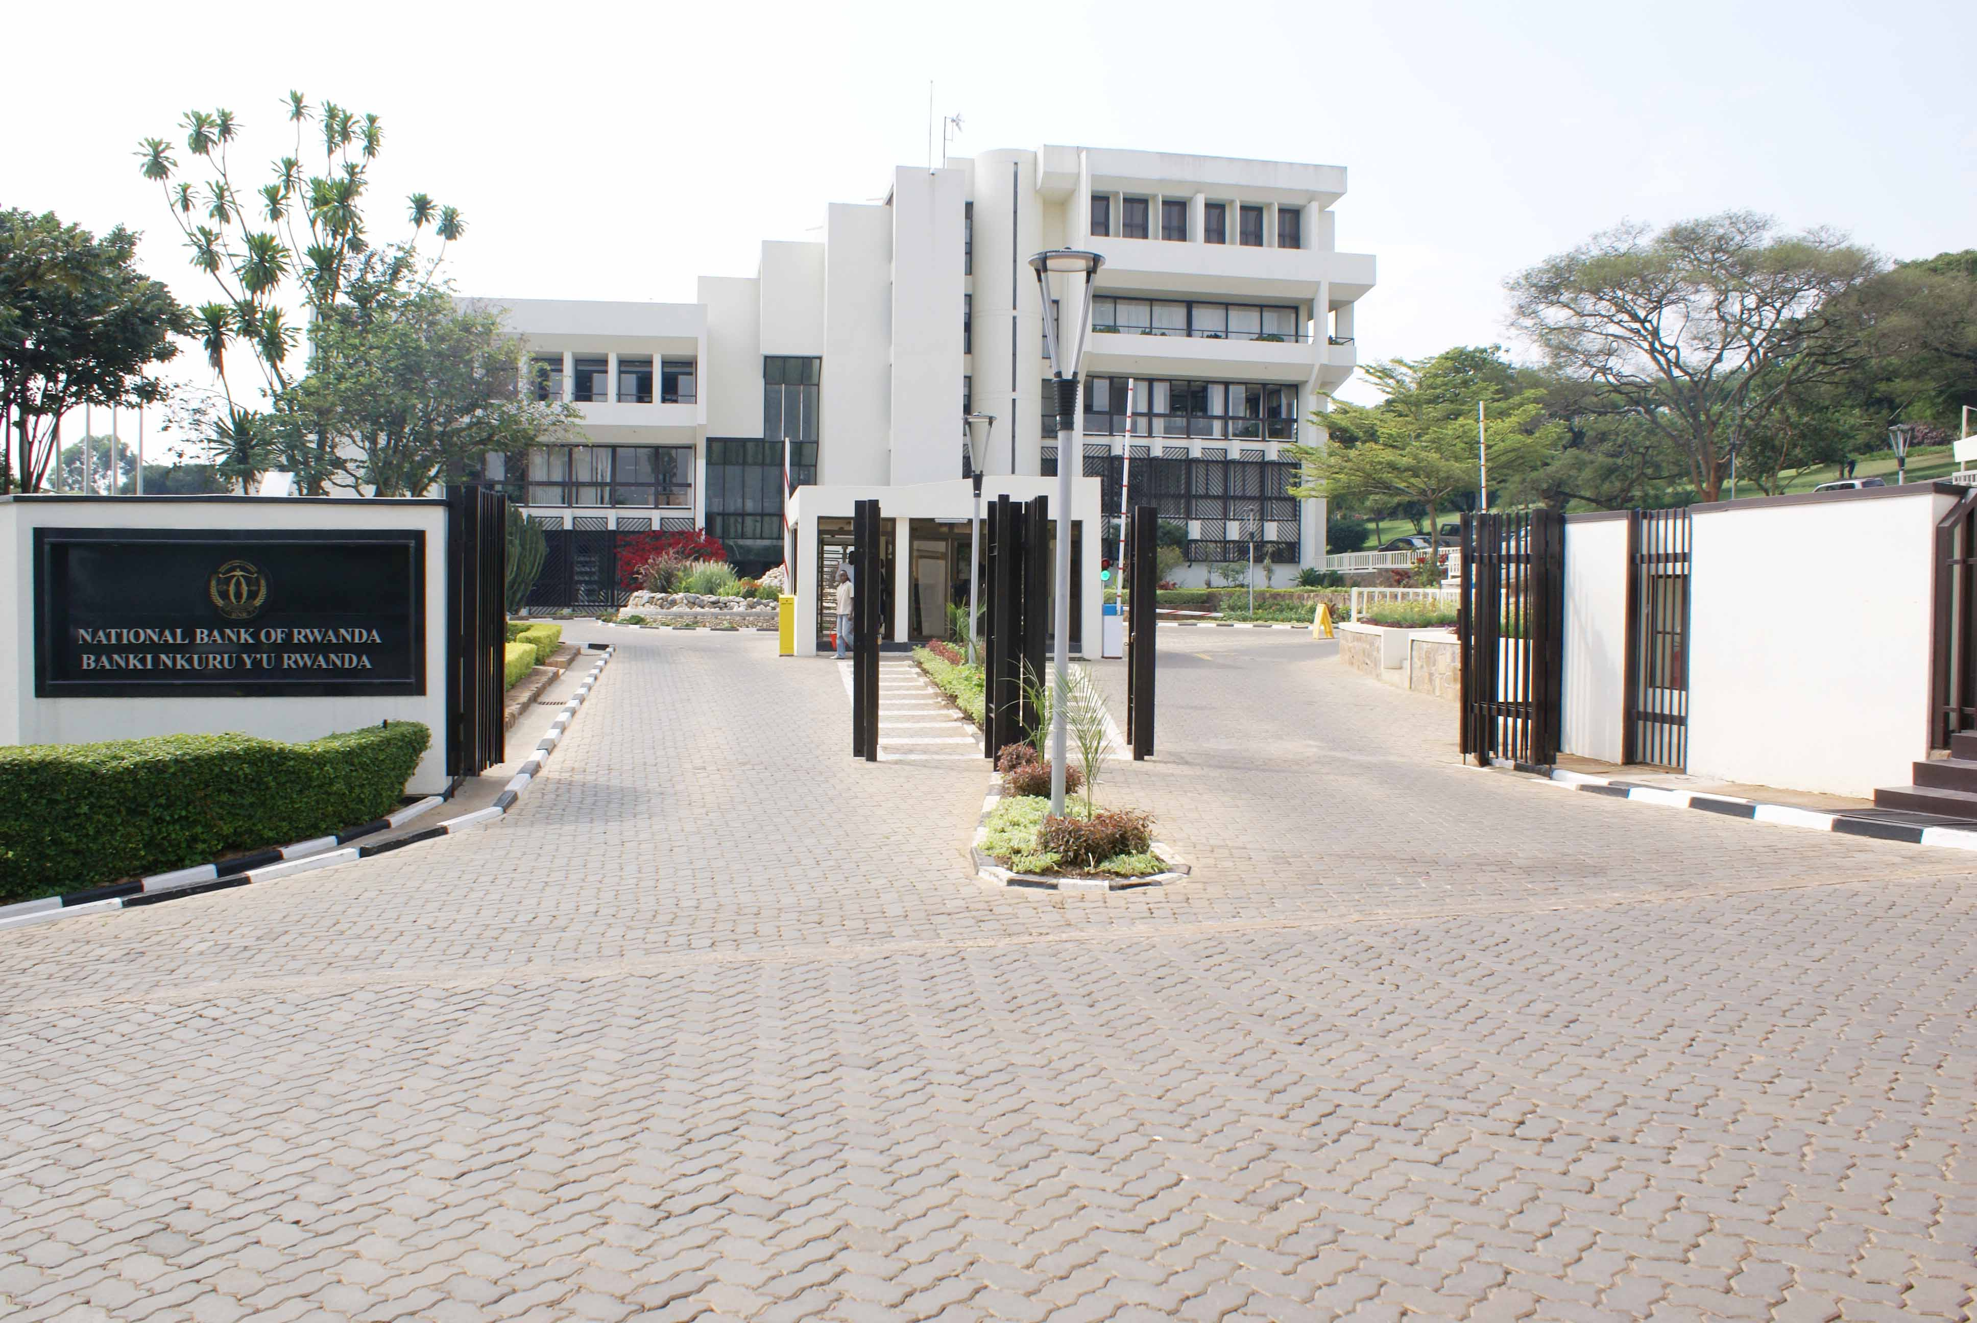

**BNR IDENTITY STATEMENT**

The National Bank of Rwanda strives to become a world class Central Bank that contributes to the economic growth and development by using robust monetary policy tools to maintain stable market prices. The bank embraces innovation, diversity and inclusiveness, economic integration and ensures financial stability in a free market economy.

**VISION, MISSION AND VALUES**

**Vision of the Bank**

The Vision of the Bank is to become a World-Class Central Bank

**Mission of the Bank**

The mission of the Bank is to ensure price stability and a sound financial system

**The Bank’s Core Values**

**Integrity**

We uphold high moral, ethical and professional standards for our people, systems and data

**Accountability**

We are results-focused and transparent, and we reward according to performance

**Mutual-respect and Team-work**

We keep ourselves in high spirit, committed to each other for success

**Excellence**

We passionately strive to deliver quality services in a timely and cost effective manner

**1. Introduction**

Since its introduction in March 2017, the bank lending survey has become an important tool for analyzing the banks’ lending conditions on Rwandan credit market. The credit survey aims to gain greater knowledge of bank lending conditions in Rwanda by capturing qualitative information on the demand and supply of credit to enterprises and households, thereby complementing the information available on the nominal amount and interest rates.

In line with the above mentioned objective, banks were asked about trends and developments in credit conditions in the first nine months of 2019 relative to the first nine months 2018, and prospects for the subsequent quarter ending December 2019. This credit survey report presents the results of the Q3 2019 survey conducted from October 14 to 18, 2018. The qualitative information contained in the survey are based on lenders’ own responses to the survey, and do not necessarily reflect the NBR’s views on credit conditions.

**2. The Survey Findings**

**2.1 The Demand for Credit**

The demand for credit is proxied by the loans applications (either in value or volume). For the purpose of this survey, loan applications refer to financing needs of new or existing customers of a bank as indicated by formal loan applications received during a specified period of time independent of whether these applications will result in a loan or not. By compiling data on loan applications, either in value or volume, the loans applications that were or are to be scrutinized at the bank board level, bank credit committee level, branch level or any other approval level as per the individual bank procedures are considered. Further, loan applications from existing clients are also counted. These include cases when the amount of an ongoing loan increases by a top up or a new loan is granted. However, modified loans which only lead to a change in the terms and conditions of the loan other than the loan size are not considered. Interbank loans and commitments are also excluded.

As banks predicted during the previous quarter, the demand for credit continued to increase during the period under review (Table 1). The findings of the survey revealed that loan applications in value increased by 27.6 percent as at end September 2019 (from FRW 832.0 billion in the first nine months of 2018 to FRW 1,062 billion in the first nine months of 2018), higher than the growth of 17.8 percent registered as at end September 2018. Similarly, loan application in volume increased by 15.2 as at end September 2019 (from 280,469 in the first nine months of 2018 to 323,118 in the first nine months of 2019), compared to the growth of 7.9 percent registered as at end September 2018. From banks’ perspective, the drivers of increased loan applications include improved economic performance that prompted more business opportunities and increased desire for spending.

**Table 1: Loan Applications in Value and Volume**

|  |  |  |  |  |  |
| --- | --- | --- | --- | --- | --- |
| Loans Applications | Sep-17 | Sep-18 | Sep-19 | % Change  17/18 | % Change  18/19 |
| Value (FRW billion) | 706 | 832 | 1,062 | 17.8 | 27.6 |
| Volume | 259,849 | 280,469 | 323,118 | 7.9 | 15.2 |

**Source:** Credit Survey Findings

**2.2 The Supply of Credit**

The survey uses two metrics to gauge the supply of credit (loans approved and loans disbursed). On one hand, loans approved consist of all cash loans approved irrespective of other requirements that a borrower has to fulfill before a loan is disbursed and they are derived from loans applications. On the other hand, loans disbursed refer to a portion of loan approved that has been credited on borrower’s account.

During the first nine months of 2019, the new authorized loans by banks grew by 41.1 percent compared to the growth of 0.3 registered in the first 9 months of 2018 (Figure 1). Between January and September 2019, banks approved 311,907 loans worthy FRW 862 billion, compared to 251,106 loans worthy FRW 611 billion that were approved during the corresponding period in 2018. The improved growth of new loans is mainly attributable to increased demand for loans consistent with the robust economic conditions and increased lending appetite by banks.

Consistent with the development in credit standards, the rejection rate[1] moderated. The overall rejection rate in value declined to 18.8 percent in September 2019 from 26.6 percent in September 2018. During the same period, the overall rejection rate in volume reduced to 3.5 percent as at September 2019 from 15.5 percent as at September 2018. Across different economic sectors, the rejection rate varied and generally reflected the risk profile of a particular activity sector. From a sample of 75 projects that were rejected by banks, it emerged that weak repayment capacity, inadequate collateral, lack of own contribution and the negative credit history were among the key reason that led to the rejection of loans applications.

Sector wise, banks continue to diversify their loans portfolio by increasing lending to other key sectors including manufacturing, water and energy and transport and communication. New lending to transport and communication sector increased by 11.8 percent to FRW 65.9 billion, while for water and energy sector, new lending increased by 238 percent to FRW 56.1 billion as at end September 2019. In particular, new lending to manufacturing continue to increase for three year in row as banks embarked on supporting made in Rwanda program. During the period under review, new loans to manufacturing sector increased by 173.7 percent (from FRW 44.5 billion as at end September 2018 to FRW 121.7 billion as at end September 2019), higher than the growth of 6.2 recorded as at end September 2018. Improving lending in other activity sectors is positive development from the financial stability perspective as the former reduces the concentration of loans in highly financed sectors including trade and mortgage whose bad performance can cause huge repercussion on banks’ balance sheet.

**Figure 1: New Authorized Loans by Banks**

**Source:** Credit Survey Findings

**2.3 The Assets Quality of Banks**

The aggregate banking sector non-performing loan ratio reduced from 6.9 percent in June 2018 to 5.6 percent in June 2019. In terms of amount, non-performing loans reduced from FRW 137.6 billion in June 2018 to FRW 125.3 billion in June 2019. The reduction of non-performing loans is attributed to three factors namely improved economic performance, increased lending and write offs. From a sectoral perspective, the NPLs ratio dropped in key sectors including the agriculture, manufacturing, mortgage, hotels, transport and communication. The reduction of NPLs ratio in these sectors mainly reflecting increased lending and write offs to these sectors during the first half of 2019.

Nevertheless, NPLs ratio increased in trade and mining. NPLs ratio in trade sector increased from 11.5 percent in June 2018 to 15 percent in June 2019. During the same period, NPLs ratio in mining sector increased from 0.6 percent to 88.4 percent. In nominal value, non-performing loans in trade increased form FRW 32.6 billion in June 2018 to FRW 45.1 billion in June 2019, while in mining NPLs increased from FRW 22 million in June 2018 to FRW 2.9 billion in June 2019. The increase of NPLs in trade and mining is attributed to few big loans that underperformed in trade and the deceleration of commodity prices that affected the exports revenues from minerals.

**Table 2: Non-Performing Loans Ratio by Activity Sector**

|  |  |  |  |
| --- | --- | --- | --- |
| NPLs Ratio (%) | Sep-17 | Sep-18 | Sep-19 |
| **Personal loans** | **6.1** | **6.3** | **5.3** |
| **Agriculture** | **17.8** | **7.9** | **5.5** |
| **Mining** | **0.9** | **0.2** | **84.3** |
| **Manufacturing** | **12.7** | **11.4** | **1.2** |
| **Water & energy** | **0.0** | **0.0** | **0.0** |
| **Mortgage** | **6.0** | **4.6** | **4.2** |
| ***Public Works*** | ***10.8*** | ***4.8*** | ***1.6*** |
| ***Residential Houses*** | ***6.1*** | ***5.2*** | ***5.2*** |
| ***Commercial Houses*** | ***3.7*** | ***3.9*** | ***4.2*** |
| **Trade** | **11.6** | **12.1** | **10.5** |
| **Hotels** | **7.2** | **12.7** | **7.7** |
| **Transport & Communication** | **2.5** | **3.2** | **1.3** |
| **OFI &Insurance** | **0.1** | **3.5** | **2.1** |
| **Other Services** | **11.5** | **10.4** | **5.5** |

**Source:** Credit Survey Findings

**2. 4 Prospects for Q4 2019**

Banks expect demand for loans to continue increasing for the remainder of 2019. In the quarter to December 2019, most banks (12 out of 16 banks) anticipate an overall increase in demand for credit that cuts across enterprises and households. Some of the major reasons given for the expected increase in demand for loans include: a) expected business opportunities resulting from improved economic performance, b) increased demand for consumer loans due to festive season and c) stable lending interest rate.

Regarding the lending interest rate movement, most banks (13 out of 16 banks) expect the overall lending interest rate to remain broadly unchanged in the quarter to December 2019. Banks cited the competition in the industry, and favorable funding conditions as the major reasons driving these expectations.

**5. List of Respondents**

|  |  |
| --- | --- |
| 1. | AB BANK RWANDA Ltd |
| 2. | ACCESS BANK RWANDA Plc |
| 3. | BANK OF AFRICA RWANDA Plc |
| 4. | BANK OF KIGALI Ltd |
| 5. | BANQUE POPULAIRE DU RWANDA Ltd |
| 6. | COMMERCIAL BANK OF AFRICA (RWANDA) Plc |
| 7. | COGEBANQUE Plc |
| 8. | DEVELOPMENT BANK OF RWANDA Plc |
| 9. | ECOBANK RWANDA Ltd |
| 10. | EQUITY BANK RWANDA Plc |
| 11. | GUARANTEE TRUST BANK RWANDA Plc |
| 12. | I&M BANK Plc |
| 13. | KCB RWANDA Ltd |
| 14. | URWEGO BANK Plc |
| 15. | UNGUKA BANK Ltd |
| 16. | ZIGAMA CSS |



1. The loan rejection rate is the ratio of the value or number of rejected loan applications by all banks to the number of loan applications received by the banks during the same period.