

**NATIONAL BANK OF RWANDA**

**BANKI NKURU Y’U RWANDA**

**QUARTERLY CREDIT SURVEY REPORT**

**SECOND QUARTER, 2020**

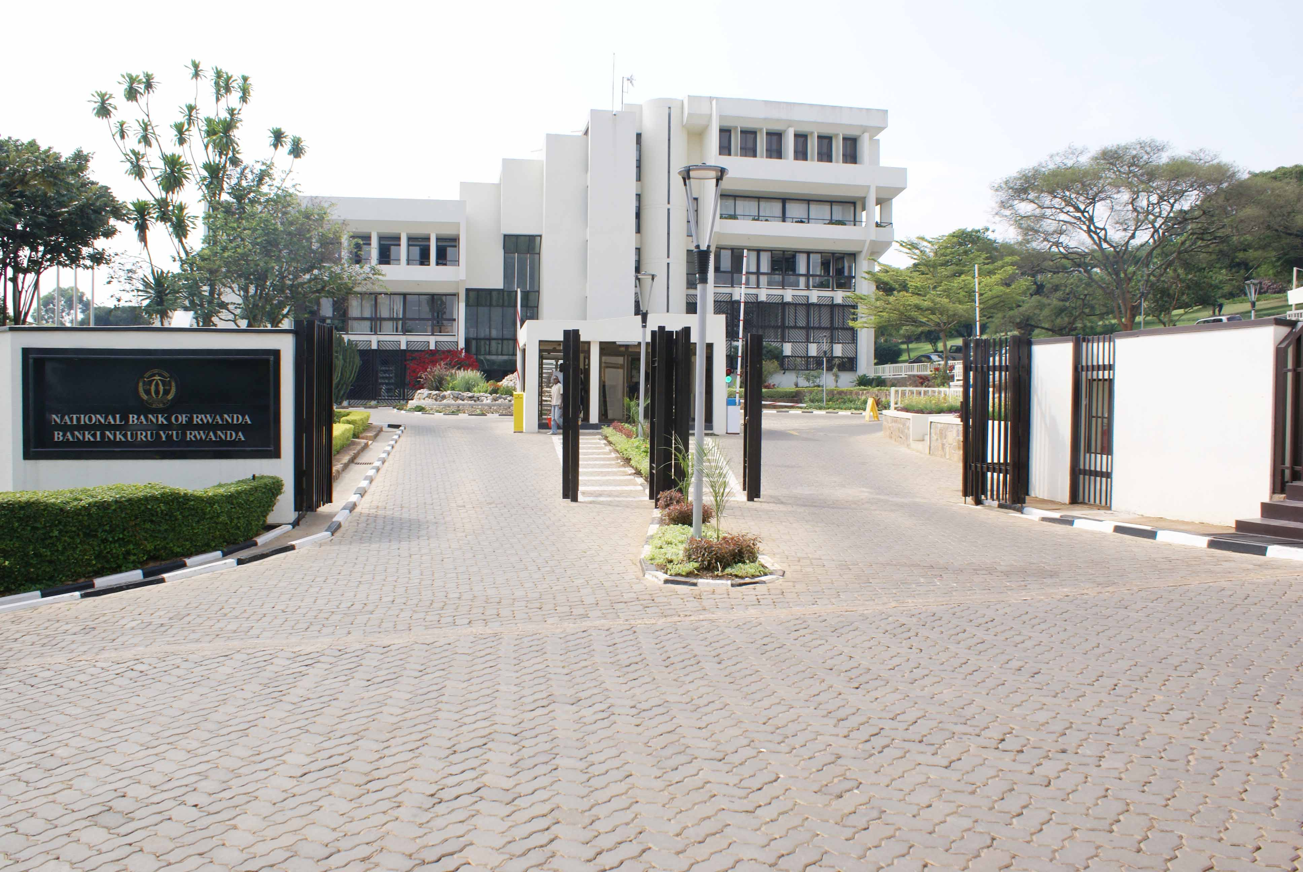

**BNR IDENTITY STATEMENT**

The National Bank of Rwanda strives to become a world class Central Bank that contributes to the economic growth and development by using robust monetary policy tools to maintain stable market prices. The bank embraces innovation, diversity and inclusiveness, economic integration and ensures financial stability in a free market economy.

**VISION, MISSION AND VALUES**

**Vision of the Bank**

The Vision of the Bank is to become a World-Class Central Bank

**Mission of the Bank**

The mission of the Bank is to ensure price stability and a sound financial system

**The Bank’s Core Values**

**Integrity**

We uphold high moral, ethical and professional standards for our people, systems and data

**Accountability**

We are results-focused and transparent, and we reward according to performance

**Mutual-respect and Team-work**

We keep ourselves in high spirit, committed to each other for success

**Excellence**

We passionately strive to deliver quality services in a timely and cost effective manner

**1. Introduction**

Understudying the trend and development in credit conditions is important for the central bank as far as the monetary policy and financial stability are concerned. The lending survey is a tool that enables the National Bank of Rwanda (NBR) to compile the information on credit market conditions directly from the banks operating on Rwandan credit market. The information that is compiled touches both the credit supply factors (credit standards and terms and conditions for approving loans as stipulated by banks) and the credit demand factors (demand for loans among households and corporates as perceived by banks) and the most significant factors underlying changes in supply and demand.

In the face of COVID-19 pandemic, the credit delivery continued to be constrained by the demand side factors. On the supply side, banks continued to hold enough capital and liquidity to support their intermediation activities and their lending capacity has been boosted by the COVID-19 policy measures that were put in place by the Government and the NBR to ease the financial and economic impact of the pandemic. This note highlights the trends and developments in credit conditions in the first half of 2020 relative to the first half of 2019, and prospects for the subsequent quarter ending September 2020. The qualitative information contained in the survey are based on lenders’ own responses to the survey, and do not necessarily reflect the NBR’s views on credit conditions.

**2. The Survey Findings**

**2.1 The Demand and Supply of Loans**

The growth of new lending continued to be hampered by economic downturn during the period under review. The banking sector new lending contracted by 9.2 percent in first half of 2020, to FRW 500.1 billion in first half of 2020 from FRW 550.8 billion in first half of 2019, compared the growth of 36.8 percent that was recorded in first half of 2019. The decline of new lending is mainly attributed to the demand side factors. During the first half of 2020, loan applications in value contracted by 12.3 percent to FRW 568.8 billion in first half of 2020 from FRW 648.6 in first half of 2019, lower than the growth of 28.3 percent recorded during the first half 2019. Similarly, the number of loans application declined by 37.9 percent, to 226,484 in first half of 2020 from 365,129 in first half of 2019, against the growth of 52.4 percent registered in the first half of 2019. The decline in overall demand for loans reflected the slowdown in economic activities due to the coronavirus pandemic.

It is important to note that since June 2020, loan applications gradually started to bounce following the government measures to ease some of the COVID-19 containment measures. The operationalization of the economic recovery fund to support sound businesses is also expected to contribute to the rebound of new lending, especially for businesses credit that are in needy of working capital to revive their operations.

**Table 1: Credit Demand and Supply**

|  |  |  |  |  |  |
| --- | --- | --- | --- | --- | --- |
| **Loan application** | **Jun -18** | **Jun-19** | **Jun-20** | **% change 18/19** | **% change 19/20** |
| **Value (FRW billion)** | **505.7** | **648.6** | **568.8** | **28.3** | **-12.3** |
| **Volume** | **239,629** | **365,129** | **226,484** | **52.4** | **-37.9** |
| **Loan approved** | **Jun -18** | **Jun-19** | **Jun-20** | **% change 18/19** | **% change 19/20** |
| **Value (FRW billion)** | **402.7** | **550.8** | **500.1** | **36.8** | **-9.2** |
| **Volume** | **164,714** | **206,519** | **177,021** | **25.4** | **-14.3** |
| **Loan rejection rate**  **(Percent)** | **Jun -18** | **Jun-19** | **Jun-20** | **% points change 18/19** | **% points change 19/20** |
| **Value** | **20.4** | **15.0** | **12.0** | **-5.4** | **3.0** |
| **Volume** | **31.3** | **43.4** | **22.0** | **12.1** | **21.4** |

**Source:** Credit Survey Findings

2.2 The assets Quality

The impact of COVID-19 is also being reflected on assets quality of banks. During the period under review, Non-Performing Loans (NPLs) increased by FRW 10.2 billion between March 2020 and June 2020 and by FRW 33.4 billion between December 2019 and June 2020. The assets quality measured as the ratio between NPLs and gross loans (NPLs ratio) stabilized around 5.5 percent as at end June 2020, the same level it was as at end March 2020. The stability of NLs ratio is attributed to :i) higher growth of loans that outpaced the growth of NPLs, ii) the improved economic performance prior to the outbreak of COVID-19 pandemic, iii) loans payments reliefs that banks have offered to their client and iv) write offs of bad loans performed by banks in the first half of 2020. is linked to the growth of outstanding loans

Sector wise, the assets quality continued to improve in agriculture in line with good agriculture performance (Table 2). The asset quality also improved in sectors including manufacturing, trade, hotels, transport and communication. In contrast, banks’ asset quality deteriorated in mortgage sector, other services sector and for consumer loans (Table 2). The deterioration of assets quality in these sector mainly reflects the effects of COVID-19 pandemic. The pandemic has had impact on assets quality in two ways: the moderation of loans and decline of income. In particular, the deterioration of assets quality in mortgage sector mainly reflect the moderation of loans in mortgage sector and the increase of NPLs for commercial real estate houses which in turn is largely linked to the decline of rental income associated with increased vacancy rates.

The other service sector is also amongst sectors that were most affected by the pandemic, mainly the education and recreation subsectors following the early closure of schools and public spaces to contain the pandemic. Further, COVID-19 pandemic has had broad impact on businesses and the employees of these businesses have been affected as well by means of loss total or part of their salaries. This has had a repercussion on debts serviceability of salaried employees and thereafter the rise of NPL in consumer loans category.

Table 2: NPLs Ratio by Economic Sector (Percent)

|  |  |  |  |  |  |
| --- | --- | --- | --- | --- | --- |
| **Activity Sectors** | **NPLs Ratio** | | | | **Percent share in total NPLs** |
| **Jun-17** | **Jun-18** | **Jun-19** | **Jun-20** |
| Personal loans | 7.2 | 6.1 | 6.0 | 7.4 | 10.8 |
| Agricultural & livestock | 18.2 | 7.2 | 5.0 | 4.8 | 1.1 |
| Mining | - | 0.6 | 88.4 | 80.4 | 2.1 |
| Manufacturing | 9.1 | 13.9 | 1.4 | 0.6 | 1.5 |
| Water & energy | 0.1 | 0.0 | - | - | 0.0 |
| Mortgage | 6.6 | 5.3 | 3.8 | 5.5 | 36.8 |
| Trade | 12.6 | 11.5 | 15.6 | 10.8 | 31.4 |
| Hotels | 8.8 | 11.0 | 8.8 | 3.8 | 6.6 |
| Transport & communication | 3.2 | 2.6 | 2.3 | 1.4 | 3.1 |
| Financial services | 0.2 | 0.4 | 1.7 | 1.0 | 0.2 |
| Other services | 11.4 | 8.9 | 6.7 | 8.2 | 6.5 |

**Source:** NBR, Financial Stability Directorate

**2.3 COVID-19 Policy Measures**

Supporting businesses that have been affected by COVID 19 is crucial for the economic recovery and long term financial sector stability. In this regards, various support measures have been introduced to ensure that the banks continue to operate smoothly by supporting the economic recovery and long-term stability. The key initiative includes the establishment of the Economic Recovery Fund (ERF) that aimed at supporting sound borrowers mostly affected by the pandemic. The ERF supplements other policy measures implemented by the NBR since 18th March 2020 to expand sources of liquidity and funding in the banking sector. These measures are all temporary and are intended to ensure that the financial sector remains stable for the duration of the shock caused by COVID-19. These measures have broadened the funding options of the banks so as to ease credit conditions and support lending to the private sector.

Further, in response to COVID-19 shock, the NBR temporarily amended some of the prudential norms to facilitate banks and encouraged them assist their customers affected by COVID-19 pandemic by offering them payment flexibility. These measures have allowed banks to provide temporary relief to financially sound clients. Banks have supported customers facing temporary income declines by offering loan restructuring options, payment deferrals and extensions to existing facilities. Although the NBR has allowed banks to give the loan payment moratorium to their customers, the implementation of such relief measures is at the discretion of the banks, who assess clients on a case by-case basis in order to determine the necessary relief applicable. As at end June 2020, banks had received 121,529 applications worth FRW 1,027 billion out of which 121,103 loans worth FRW 978 billion have been restructured, equivalent to 39 percent of total loan portfolio of the banking sector.

**2.4 The Expectations for Q3 2020**

Banks foresee a gradual increase of new lending during the quarter ending September 2020. Most banks (9 banks) anticipate improved new lending in third quarter 2020 compared to the previous quarter on account of resumption of businesses, increased business credit demand and stable credit standards. Further banks expect the lending interest rate to remain broadly unchanged as well. The survey results indicate that majority of the banks (10 banks) expect their lending rates to remain unchanged, while 2 banks expect the lending interest rate increase and other 4 banks anticipate the lending interest rate to drop. Banks cited the competition in the industry, favorable liquidity conditions and COVID-19 support measures as the major reasons driving these expectations on interest rate movement.

**3. List of Participants**

|  |  |
| --- | --- |
| 1. | AB BANK RWANDA Plc |
| 2. | ACCESS BANK RWANDA Plc |
| 3. | BANK OF AFRICA RWANDA Plc |
| 4. | BANK OF KIGALI Plc |
| 5. | BANQUE POPULAIRE DU RWANDA Plc |
| 6. | NCBA BANK RWANDA Plc |
| 7. | COGEBANQUE Plc |
| 8. | DEVELOPMENT BANK OF RWANDA Plc |
| 9. | ECOBANK RWANDA Plc |
| 10. | EQUITY BANK RWANDA Plc |
| 11. | GUARANTEE TRUST BANK RWANDA Plc |
| 12. | I&M BANK RWANDA Plc |
| 13. | KCB BANK RWANDA Plc |
| 14. | URWEGO BANK Plc |
| 15. | UNGUKA BANK Plc |
| 16. | ZIGAMA CSS |

