

**NATIONAL BANK OF RWANDA**

**BANKI NKURU Y’U RWANDA**

**QUARTERLY CREDIT SURVEY REPORT**

**QUARTER ONE 2019**

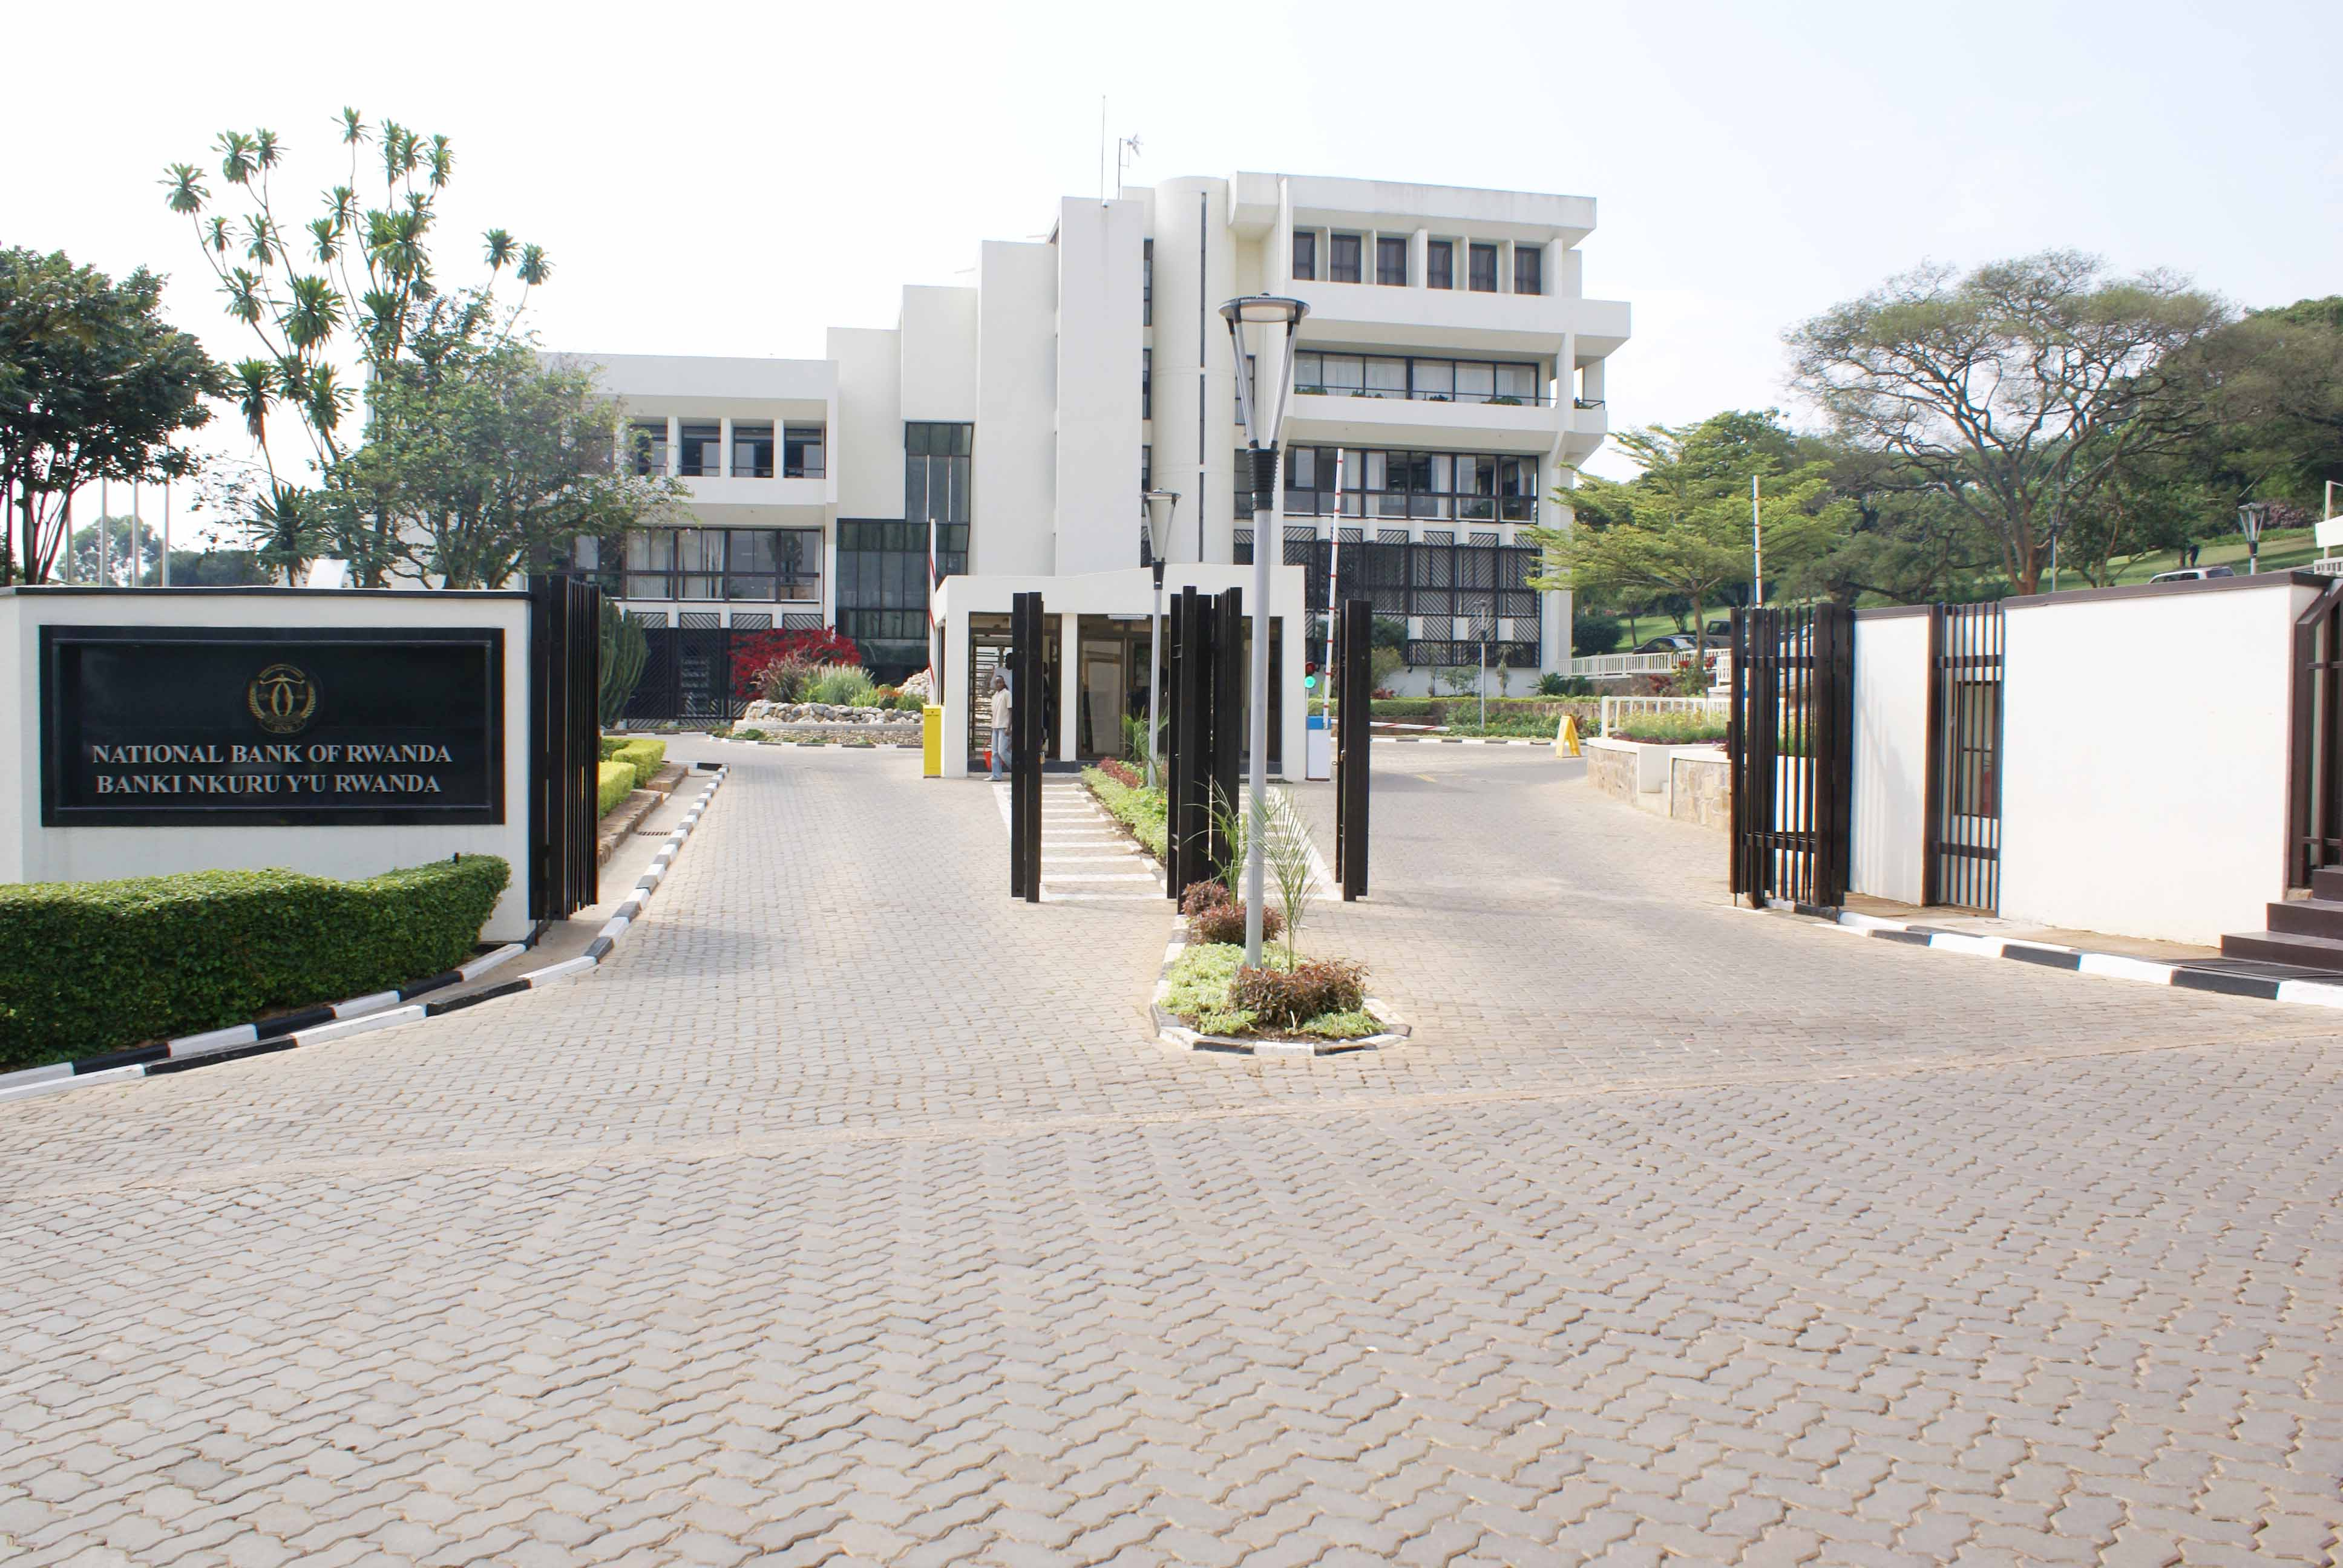

**BNR IDENTITY STATEMENT**

The National Bank of Rwanda strives to become a world class Central Bank that contributes to the economic growth and development by using robust monetary policy tools to maintain stable market prices. The bank embraces innovation, diversity and inclusiveness, economic integration and ensures financial stability in a free market economy**.**

**VISION, MISSION AND VALUES**

**VISION OF THE BANK**

The Vision of the Bank is to become a World-Class Central Bank

**MISSION OF THE BANK**

The mission of the Bank is to ensure price stability and a sound financial system

**THE BANK’S CORE VALUES**

**INTEGRITY**

We uphold high moral, ethical and professional standards for our people, systems and data

**ACCOUNTABILITY**

We are results-focused and transparent, and we reward according to performance

**MUTUAL-RESPECT AND TEAMWORK**

We keep ourselves in high spirit, committed to each other for success

**EXCELLENCE**

We passionately strive to deliver quality services in a timely and cost effective manner

**1. Introduction**

The National Bank of Rwanda (BNR) conducts the bank lending survey on quarterly basis. The main objective of the bank lending survey is to supplement information on credit market conditions, in order to broaden the assessment of financial developments as an input into financial stability and monetary policy decisions. Findings from the survey also facilitate preparation of economic forecasts as information regarding expected changes in credit conditions could enhance the precision of economic projections.

The lending survey is conducted through a structured questionnaire that enables the NBR to obtain quantitative and qualitative information directly from banks operating on Rwandan credit market. The questionnaire focuses on both the credit supply side (credit standards and terms and conditions for approving loans as stipulated by banks) and the credit demand side (demand for loans among households and enterprises as perceived by banks), and entails the most significant factors underlying changes in supply and demand.

The credit survey covers not only the observed evolution of credit standards and credit demand in the previous periods, but also the expected developments in the near future. The questionnaire is addressed to senior credit officers of banks to indicate their banks’ position in terms of demand for credit, approval of credit, credit standards and terms and conditions. The recent bank lending survey was conducted in April 2019, covering three months period between January and March 2019. The qualitative information contained in the survey are based on lenders’ own responses to the survey, and do not necessarily reflect the NBR’s views on credit conditions.

**2. The Bank Lending Survey Results**

**2.1 The Demand and Supply of Credit**

As banks predicted in January 2019, the demand for credit[1] increased in the first quarter of 2019. The value of loan applications increased from FRW 264.5 billion in the first quarter of 2018 to FRW 326.1 billion in first quarter of 2019, while the volume of loan applications increased from 101,080 in the first quarter of 2018 to 118,935 in first quarter of 2019, representing an increase of 23.3 percent in value and 17.6 in volume. The increased in demand for loans is mainly attributed to the increase in consumption expenditure and financing needs in line with the economic development.

With regards to the supply of loans, new authorized loans by banks grew by 24.9 percent (from FRW 197.9 billion in first quarter of 2018 to FRW 247.2 billion in the first quarter 2019), compared to a decline of 7.4 percent recorded in the first quarter 2018. During the first quarter of 2019, banks approved 98,993 loans worth FRW 247.2 billion, compared to 79,289 loans worth FRW 197.9 billion that were approved in the first quarter of 2018. The growth of new loans is mainly attributable to a combination of increased demand for loans and lending appetite of banks. In this regards, the loan approval rate (which measures the proportion of loans approved vis a vis the total loans applied), increased from 74.9 percent in first quarter of 2018 to 75.8 percent in the first quarter of 2019 in value and from 78.5 percent in the first quarter of 2018 to 83.3 percent in the first quarter of 2019 in volume.

**Figure 1: New Authorized Loans by Banks**

**Source:** Credit Survey Findings

The financing of manufacturing sector improved during the period under review. New loans in manufacturing sector increased by 195.6 percent to FRW 30.5 billion in the first quarter of 2019 from FRW 10.3 billion in the first quarter 2018. The growth of new loans also improved for consumer loans (from 7.8 percent to 34.9 percent), agriculture (from -1.0 percent to 6.6 percent), mining (from -93.6 percent to 77 percent), energy (from -97.7 percent to 10,054.7 percent), hotels (from -80.2 percent to 1,362.8 percent) and mortgage (from -7.6 percent to 1.7 percent).

Unlike in the previous year, the financing of transport and communication sector shrunk. New loans in transport and communication reduced by 31.5 percent (to FRW 22.6 billion in the first quarter of 2019 from FRW 32.9 billion in the first quarter of 2018), after they had grown by 67.6 percent in the first quarter of 2018. The reduction of new loans in transport and communication sector is linked to the deterioration of assets quality in this sector. Lending also moderated in trade and other services[2]. New loans in trade sector declined by 1.4 percent in the first quarter of 2019, in addition to a contraction of 20.8 percent observed in the first quarter of 2018. New loans in other services contracted to 2.6 percent in the first quarter of 2018 from a growth of 66.6 percent in the first quarter of 2018. The deceleration of new loans mainly reflects the slowdown of credit demand in transport and communication sector and the perception of risks by banks in trade sector given unsatisfactory performance of existing portfolio. In this regard, the rejection rate[3] in trade sector increased to 31.9 percent in in the first quarter of 2019 from 23.3 percent in the first quarter of 2018.

**Table 1: New Authorized Loans by Activity Sector**

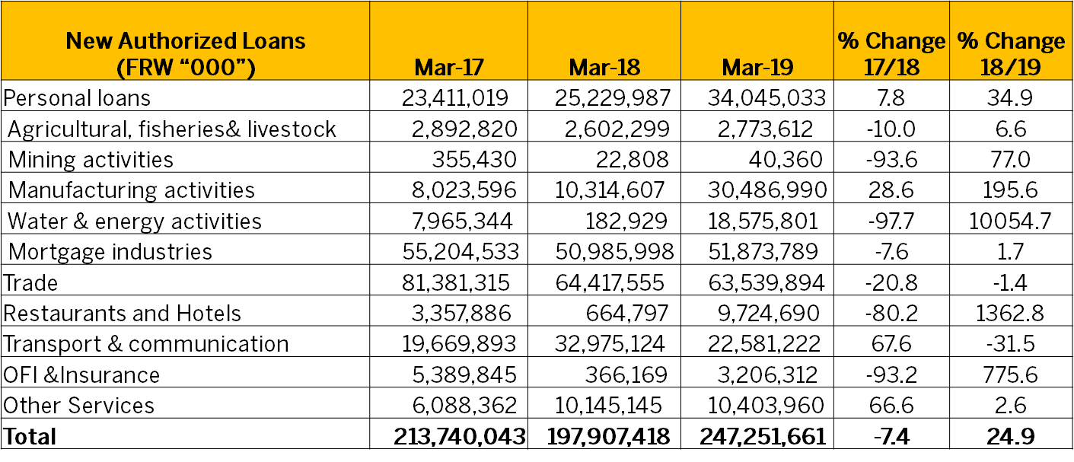**Source:** Credit Survey Findings

**2.2 Development in Non-Performing Loans**

Overall, the non-performing loans ratio in banks remained stable standing at 6.8 percent as at end March 2019. From a sectoral perspective, assets quality in agriculture sector continued to improve in line with improved performance of this sector. In this end, NPLs ratio in the agriculture sector dropped from 7.3 percent in March 2018 to 5.9 percent in March 2019 (Table 2). Assets quality also significantly improved in manufacturing sector. The ratio of non-performing loans to gross loans in manufacturing sector reduced from 12.5 percent in March 2018 to 9.3 percent in March 2019. There were also some marginal reduction of non-performing loans ratio in mortgage, trade and in hotels. Unlikely, NPLs ratio increased for personal loans (from 6 percent to 6.6 percent), mining (from 0.7 percent to 60.3 percent), transport and communication (from 2.6 percent to 2.9 percent), financial sector (from 0.3 percent to 3.7 percent) and other services (from 9 percent to 10.7 percent).

**Table 2: Non Performing Loans Ratio by Activity Sector**

|  |  |  |  |  |
| --- | --- | --- | --- | --- |
| **Activity Sector** | **NPLs Ratio (%)** | | | |
| **Mar-16** | **Mar-17** | **Mar-18** | **Mar-19** |
| Personal loans | 8.1 | 5.4 | 6 | 6.6 |
| Agricultural, fisheries and livestock | 24.9 | 10 | 7.3 | 5.9 |
| Mining activities | 0 | 0.7 | 0.7 | 60.3 |
| Manufacturing activities | 9 | 13.9 | 12.5 | 9.3 |
| Water & energy activities | 0.2 | 0 | 0 | 0.0 |
| Mortgage industries | 8.2 | 4.5 | 4.8 | 4.3 |
| Trade | 12.3 | 12 | 11.6 | 11.4 |
| Hotels and Restaurants | 9.4 | 11.6 | 11.4 | 9.7 |
| Transport & communication | 3.4 | 2.4 | 2.6 | 2.9 |
| OFI &Insurance | 0.2 | 0.2 | 0.3 | 3.7 |
| Other Services | 8 | 11.2 | 9 | 10.7 |

**Source:** Credit Survey Findings

**2.3 Credit Standards, Terms and Conditions**

Credit standards consist of internal banking guidelines which will determine what type of loans and amount to be provided and to which clients. They mainly embody capacity of the borrower, collateral requirements, borrowers’ own contribution to the project and credit history of the borrower. The credit survey measures changes in such standards including cases where a bank has introduced a new lending policy or amended existing one. Most banks (12 banks out of 16 banks) reported that their credit standards remained unchanged during the first quarter of 2019, whereas four banks reported to have tightened their credit standards. The key reasons cited for tightening are mainly bank specific factors, including bank perception of risk and the desired securitization level.

Like credit standards, the credit terms and conditions[4] also remained broadly unchanged. Out of 16 banks operating on Rwandan credit market, 11 banks indicated that their overall terms and conditions remained unchanged, while 3 banks indicated that credit terms and conditions tightened and 2 banks indicated that the credit terms and conditions eased. From banks’ perspective, operating costs and the perception of risk were the main reasons for tightening credit terms and conditions while the competition, cost of funds and liquidity position were the main factors that contributed to easing of credit terms and conditions. In context of this survey, the easing of credit terms and conditions mainly characterizes the reduction of lending interest rate and the extension of maturity for mortgage loans.

**Figure 2: Credit Standards, Terms and Conditions**

**Source:** Credit Survey Findings

**2.4. Banks’ Expectations for Q2 2019**

Overall, the majority of banks expect lending to continue increasing in Q2 2019. Twelve banks, one bank more than eleven banks in the previous survey expect an increase of lending in the next three months period to June 2019. These expectations of banks are mainly based on improvement in macroeconomic environment that is expected to continue in the period ahead. Other factors such as increased liquidity in banking sector, the financing needs of households and corporates are also expected to contribute to increase lending in Q2 2019. With regards to the lending interest rate, the survey results indicate that majority of the banks (11 banks out of 16 banks) expect their lending rates to remain unchanged over the next quarter to June 2019. Banks’ expectation on lending interest rate hinge on the liquidity conditions in banking sector and banks’ efforts to remain competitive in the market.

**Figure 3: Bank’s Expectations for Q2 2019**

**Source:** Credit Survey Findings

**Annex 1: List of Respondents**

1. AB BANK RWANDA Ltd

2. ACCESS BANK RWANDA Plc

3. BANK OF AFRICA RWANDA Plc

4. BANK OF KIGALI Plc

5. BANQUE POPULAIRE DU RWANDA Ltd

6. COGEBANQUE Plc

7. COMMERCIAL BANK OF AFRICA RWANDA Plc

8. DEVELOPMENT BANK OF RWANDA Plc

9. ECOBANK RWANDA Ltd

10. EQUITY BANK RWANDA Plc

11. GT BANK RWANDA Plc

12. I&M BANK Plc

13. KCB RWANDA Ltd

14. UNGUKA BANK Ltd

15. URWEGO BANK Plc

16. ZIGAMA CSS



1. Demand for credit refers to the demand for new loans by borrowers as indicated by the volume and value of applications received.
2. This includes health, education and professional activities.
3. The loan rejection rate is the ratio of the value or number of rejected loan applications by all banks to the number of loan applications received by the banks during the same period.
4. credit terms and conditions are terms and conditions on which a bank provides credit to a customer after it has been approved. They mainly include the interest rate, maturity and frequency of payment.